Phase 3 – Forensic Analysis, Interpretation, and Final Reporting

By Wendel Jackson

Introduction
After the completion of Phase 2, the next step is to conduct an actual investigation and interpret what happened.

Evidence Summary

Disk Image Analysis
- Autopsy was used to analyze the image file from the host computer.
- The disk image was loaded into Autopsy
- Unknown exe was found in C:\Users\wende\Desktop\SUSPICIOUSFOLDER
Other unknown exe were found such as KiloHearts Installer.exe and parsec-windows.exe.
- A suspicious .txt file was found.

Memory Analysis
- Volatility was used to analyze recent volatile memory activity.
- Volatility is ran:
vol –f physmem.raw windows.pslist
- Suspicious .exe files were found running.
Below are the data files that were analyzed.
Image File: Image.ad1
Hash Value: c13873ac5f81932d3f4118454c012bc4642187828a17f1784f03cefcb41b25c0
File Size: 10.3 MB
Storage Location: /home/wendel/evidence

Memory Dump File: physmem.raw
Hash Value: f29035292d47d3f667ee7411f7e0a9226589dc1440538cd74c3bcc23902f3994
File Size: 17.4 GB
Storage Location: /home/wendel/evidence/physmem.raw

Timeline:
4/18/26 15:40:04 AUEPOU.exe
4/18/26 15:40:40 Greenshot.exe
4/18/26 15:43 atieah64.exe
4/20/26 16:17 aimgr.exe
4/20/26 16:17 ai.exe

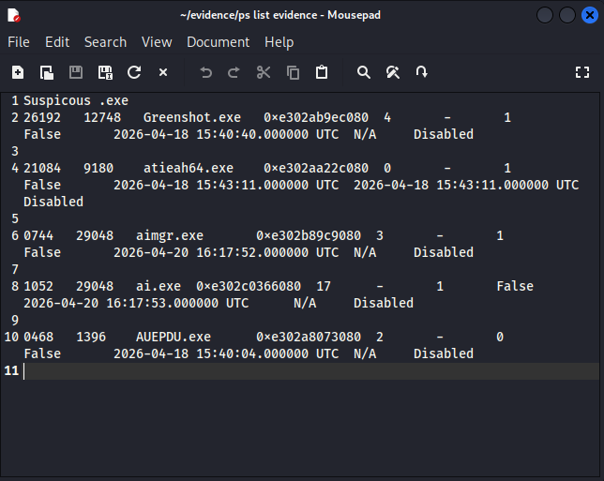

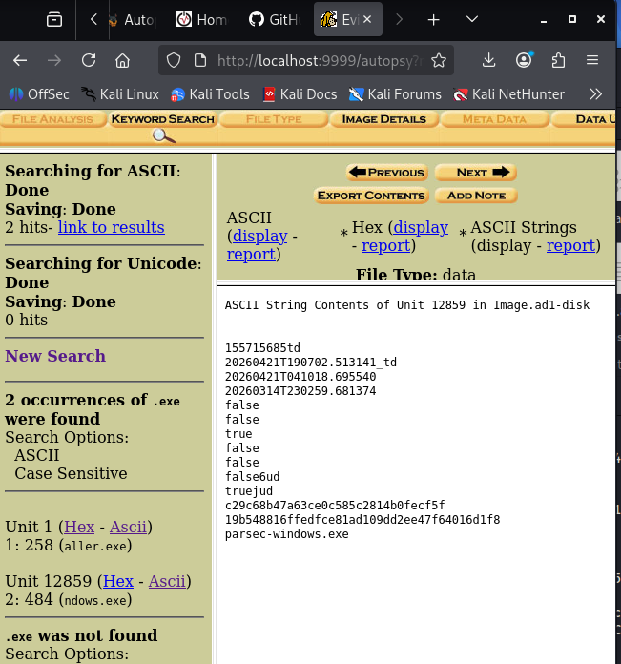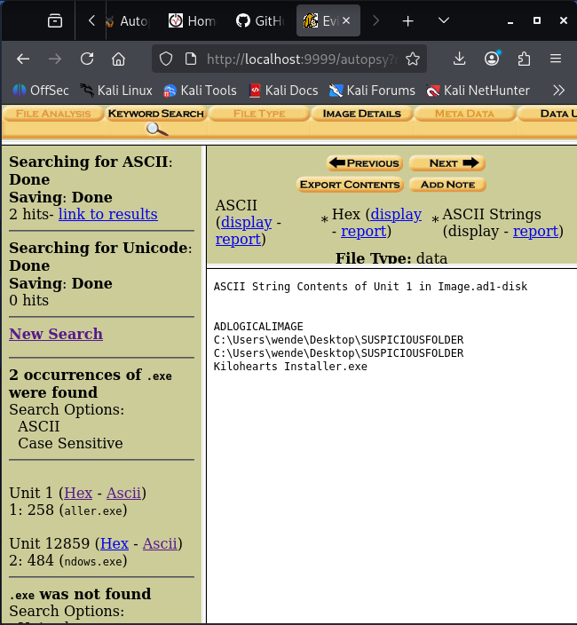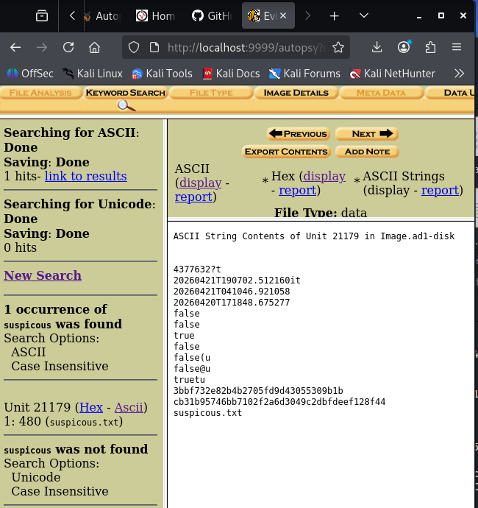

Conclusion and Assessment
Based on the evidence collected, we can determine that the host machine has been showing signs of suspicious activity beginning on 4/18, including the execution of other unknown .exe files and appearance of more programs.
From this evidence, we can determine that the user may have downloaded an application from the internet which likely led to the potential compromise. One file called parsec-windows.exe, was identified and flagged as malicious during analysis via VirusTotal. Although parsec is a legitimate application, in this case it may have been an unauthorized version that was downloaded. The other suspicious apps and .exe files may have been installed via the parsec application. Another red flag is the file being located in the SUSPICIOUSFOLDER directory instead of the usual downloads folder.
